**USI CBO CE - API&I LnD**

**Workato Academy**



Workato Academy

Integration Developer Learning Guide

Created BY: Ajit Tejankar/ Surya Gannavarapu

Integration Developer Certification

Registration Link : [https://academy.workato.com/integration-developer-certification?_gl=1*hmahoo*_gcl_au*OTQ1ODk5NTk2LjE3MTkzMDcxNTc](https://academy.workato.com/integration-developer-certification?_gl=1*hmahoo*_gcl_au*OTQ1ODk5NTk2LjE3MTkzMDcxNTc).

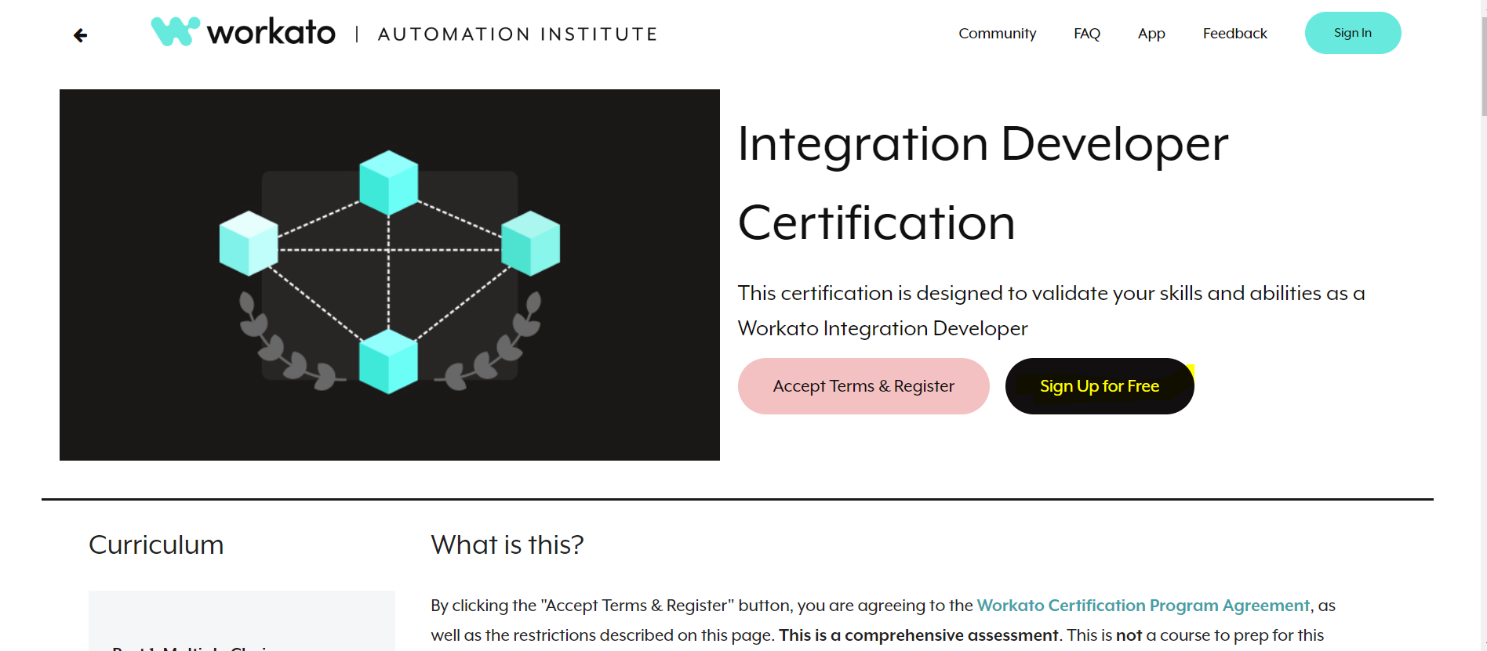

**Step 1:** Sign Up(outlook.com,gmail.com wont support as it prompts to enter a valid email n if you provide a valid work mail id then on that mail you will get workato Account Activation link,once you activate then only it allows u to enter in portal so u need to have access to the work mail which you will provide for signing up, n one work mail can be used only for once that means we cannot use same work mail with diff uname combination as it prompts to Account Cannot be created that means u will have same mail id registered with some diff uname already)

**Step 2:** Accept terms & Register for the Integration Developer Certification –this is the certification exam purchase link which costs $300)

**Step 3:** Complete the courses for each Automation Pro Development n Deloitte will provide you a voucher for free certification of integration developer certificate exam.

**Course Links:**

|  |  |  |
| --- | --- | --- |
| # | Topic | Link |
| 1 | Automation Pro I On Demand | <https://academy.workato.com/path/integration-developer/automation-pro-i-on-demand> |
| 2 | Automation Pro I Exam | <https://academy.workato.com/path/integration-developer/enterprise-automation-i-exam> |
| 3 | Automation Pro II On Demand | <https://academy.workato.com/path/integration-developer/automation-pro-ii-revised> |
| 4 | Automation Pro II Exam | <https://academy.workato.com/path/integration-developer/enterprise-automation-ii-exam> |
| 5 | Transforming Data with Formulas | <https://academy.workato.com/path/integration-developer/transforming-data-with-formulas> |
| 6 | Error Troubleshooting | <https://academy.workato.com/path/integration-developer/error-troubleshooting/825309/scorm/1e8sntof67rsq> |
| 7 | CSV Tools by Workato | <https://academy.workato.com/path/integration-developer/processing-csv-files> |
| 8 | Task Optimization | <https://academy.workato.com/path/integration-developer/task-optimization> |
| 9 | Using Recipe Functions | <https://academy.workato.com/path/integration-developer/using-recipe-functions> |
| 10 | Recipe Lifecycle Management for Environments | <https://academy.workato.com/path/integration-developer/recipe-lifecycle-management-for-environments> |
| 11 | Batch/Bulk Processing | <https://academy.workato.com/path/integration-developer/batchbulk-processing> |
| 12 | Working with Databases | <https://academy.workato.com/path/integration-developer/working-with-databases> |
| 13 | Applying RecipeOps | <https://academy.workato.com/path/integration-developer/applying-recipeops/740432/scorm/a8umrqe2lxwc> |
| 14 | HTTP Connector | <https://academy.workato.com/path/integration-developer/http-connector> |
| 15 | Collection by Workato | <https://academy.workato.com/path/integration-developer/collection-by-workato> |
| 16 | Automation Pro III Exam | <https://academy.workato.com/path/integration-developer/automation-pro-iii-exam> |

**Course Timelines**

# Total of 2 weeks (effective duration) self-paced learning sessions and 2 doubt clearing check points(1 Hour each). The program is from 25th of June 2024 till 2nd of August for both the courses. Please find below the dates for individual courses,

Learning start date for developer Pathway– 6/25

Learning end date for developer Pathway  – 7/12

Learning start date for Architect Pathway – 7/15

Learning end date for Architect Pathway  – 8/02